Kubernets Task-3
- Create a ClusterIP service for an Apache web server pod.
- Expose an Nginx pod externally using a NodePort service.
- Deploy a ReplicationController to maintain 3 replicas of an Nginx pod.
- Scale the ReplicationController from 3 replicas to 5 replicas.
- Create a ReplicaSet to manage pods based on multiple labels (prod and test).
- Deploy a ReplicaSet that excludes pods with the label backend.
- Test load balancing across multiple pods using a Node Port service.
- Delete a Replication Controller without affecting the running pods.

1.Step:1
Firstly, I have created Vi apache-pod.yml
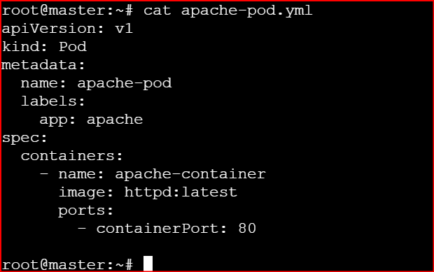

kubectl apply -f apache-pod.yml

Step2:
Then I have created service as: vi apache-service.yml

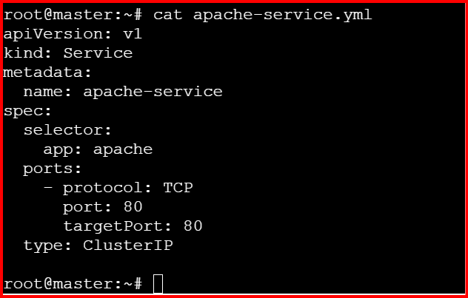
kubectl apply -f apache-service.yml
Kubectl get pods
Kubectl get svc

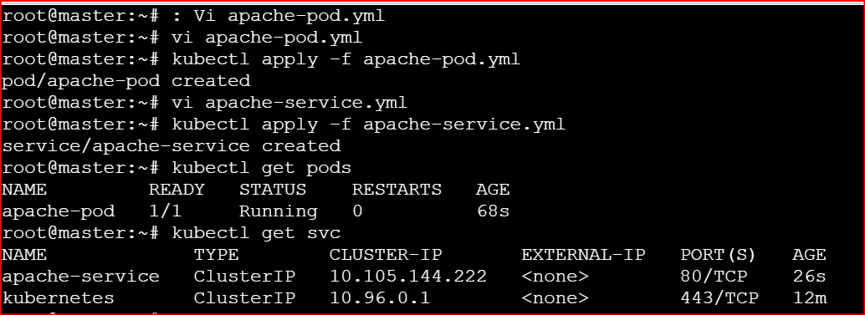
Verify Service is linked to Pod
kubectl describe svc apache-service
You should see: selector: app= apache
Endpoints: 10.244.0.12:80
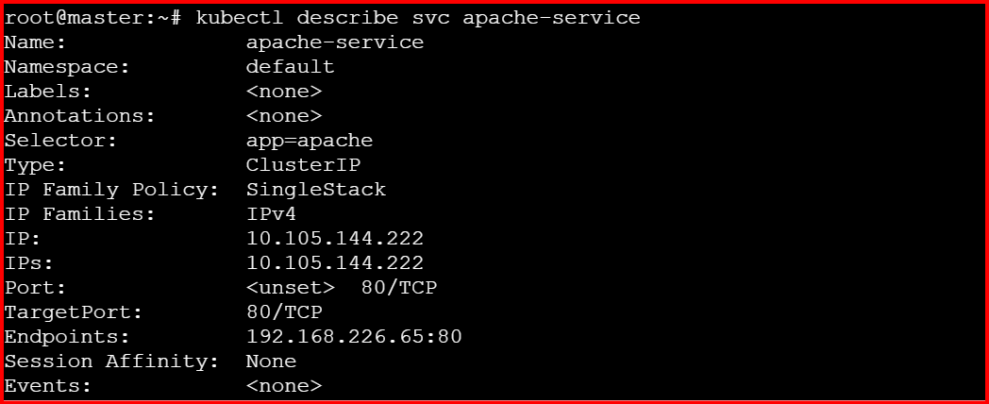
The Endpoints section confirms the Pod is connected to the Service
Now test the pod using busybox entering inside the cluster
kubectl run test-pod --image=busybox -it --rm -- sh
wget -qO- http://apache-service
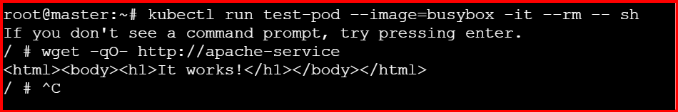

2.Expose an Nginx pod externally using a NodePort service
Create vi nginx-pod.yml
--------------------------------------------------------------------------------------------------
apiVersion: v1
kind: Pod
metadata:
name: nginx-pod
labels:
app: nginx
spec:
containers:
- name: nginx-container
image: nginx:latest
ports:
- containerPort: 80
---------------------------------------------------------------------------------------------------------------------------
kubectl apply -f nginx-pod.yml
Now create service.yml file as: vi nginx-service.yml
---------------------------------------------------------------------------------------------------------------------------
apiVersion: v1
kind: Service
metadata:
name: nginx-nodeport-service
spec:
type: NodePort
selector:
app: nginx
ports:
- protocol: TCP
port: 80
targetPort: 80
nodePort: 30080
-------------------------------------------------------------------------------------------------------------------------
kubectl apply -f nginx-service.yml
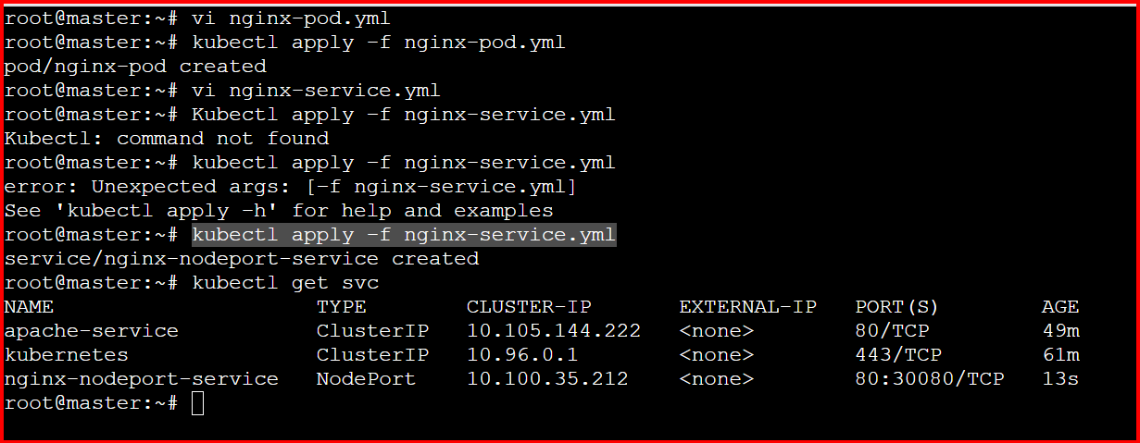

Check with master ip /30080
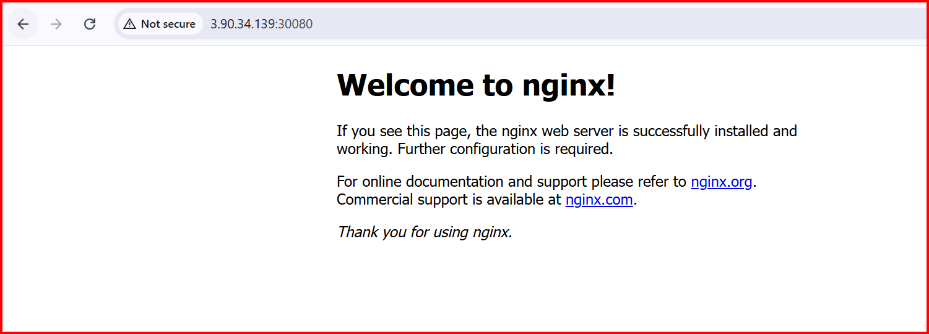

3.Deploy a ReplicationController to maintain 3 replicas of an Nginx pod.

Create vi nginxrc.yml
-----------------------------------------------------------------------------------------------------------------------------
apiVersion: v1
kind: ReplicationController
metadata:
name: nginx-rc
labels:
app: nginx
spec:
replicas: 3
selector:
app: nginx
template:
metadata:
labels:
app: nginx
spec:
containers:
- name: nginx-container
image: nginx:latest
ports:
- containerPort: 80
-------------------------------------------------------------------------------------------------------------------------------
kubectl apply -f nginxrc.yml
kubectl get rc
kubectl get pods -l app=nginx
kubectl get pods
#3 pods will b running.
Now have delete a pod
kubectl delete pod nginx-rc-9qmjh
And check again
kubectl get pods -l app=nginx
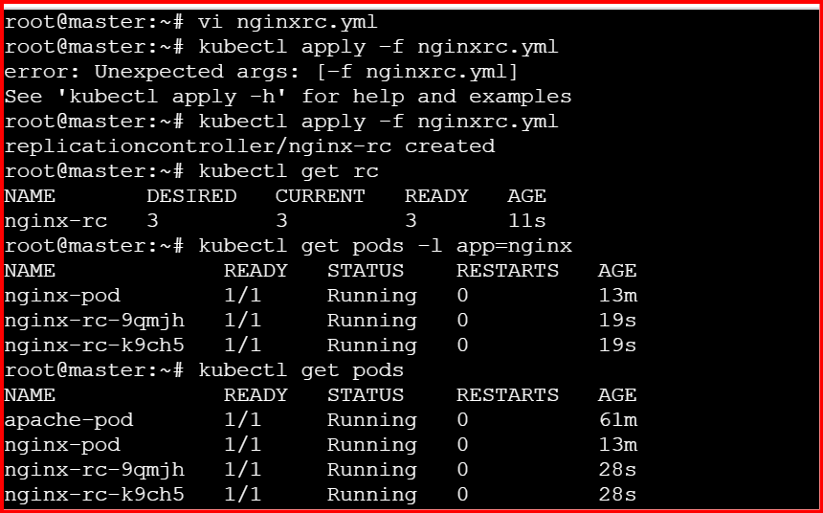

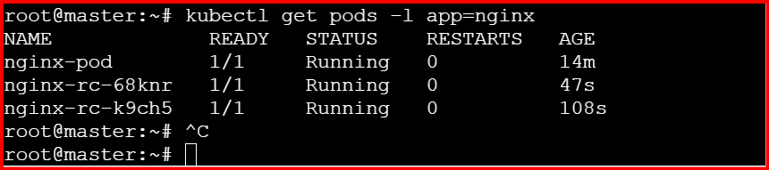

4.Scale the ReplicationController from 3 replicas to 5 replicas.

We can scale the pods in two ways.
- Using the command
- Using the yaml file editing.
kubectl scale rc nginx-rc --replicas=5
kubectl get pod
kubectl scale rc nginx-rc --replicas=5
kubectl get pod
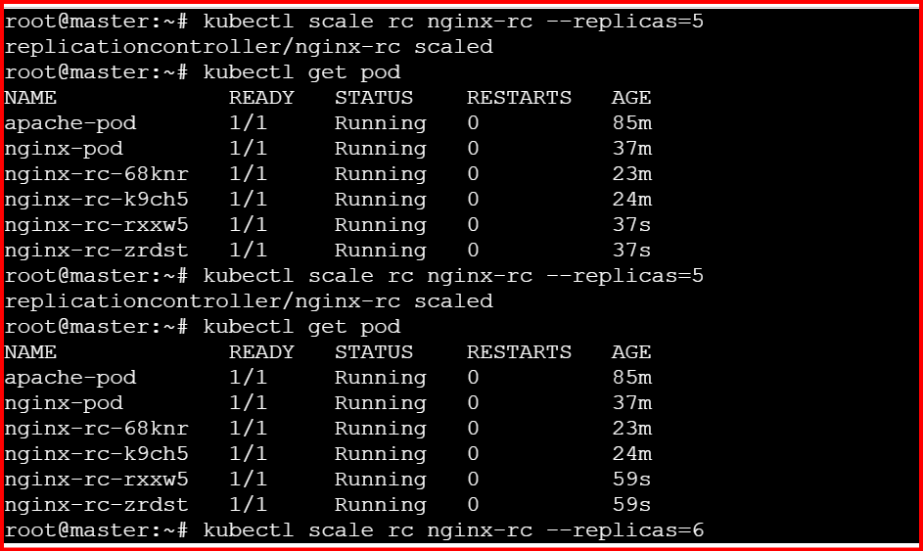

5.Create a ReplicaSet to manage pods based on multiple labels (prod and test).

Firstly, I have created the replicaset as follows: vi replicaset.yml
-----------------------------------------------------------------------------------------------------
apiVersion: apps/v1
kind: ReplicaSet
metadata:
name: nginx-replicaset
labels:
app: nginx
spec:
replicas: 3
selector:
matchExpressions:
- key: app
operator: In
values:
- nginx
- key: env
operator: In
values:
- prod
- test
template:
metadata:
labels:
app: nginx
env: prod
spec:
containers:
- name: nginx-container
image: nginx:latest
ports:
- containerPort: 80
-----------------------------------------------------------------------------------------------------------------------------
Give the below commands

kubectl apply -f replicaset.yml
kubectl get rs
kubectl get pods -l app=nginx
Replica-set has been created

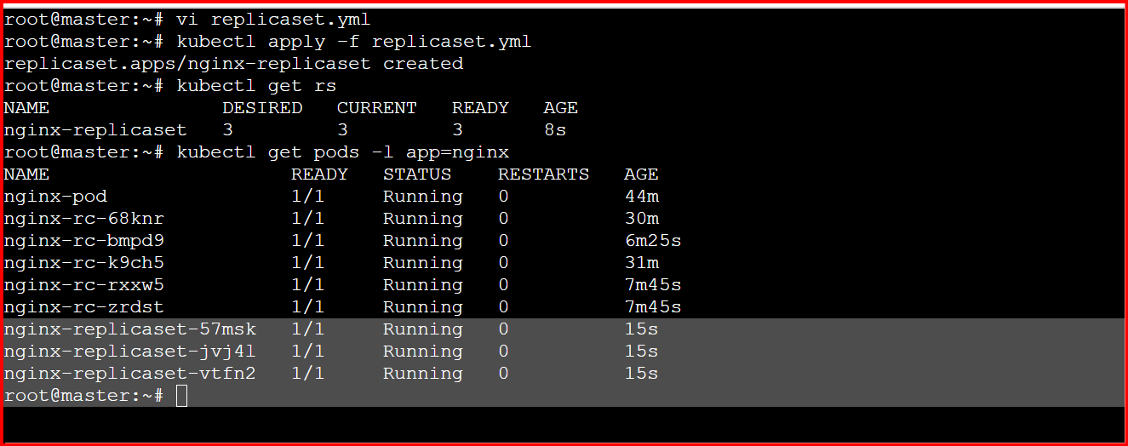
6.Deploy a ReplicaSet that excludes pods with the label backend
Firstly, I have created the backend as follows: Vi backend.yml
----------------------------------------------------------------------------------------------------------------------------
apiVersion: apps/v1
kind: ReplicaSet
metadata:
name: nginx-exclude-backend-rs
labels:
app: nginx
spec:
replicas: 3
selector:
matchExpressions:
- key: app
operator: In
values:
- nginx
- key: tier
operator: NotIn
values:
- backend
template:
metadata:
labels:
app: nginx
tier: frontend
spec:
containers:
- name: nginx-container
image: nginx:latest
ports:
- containerPort: 80
-----------------------------------------------------------------------------------------------------------------------------------
kubectl apply -f backend.yml
kubectl get rs
kubectl get pods -l app=nginx
kubectl run backend-pod --image=nginx --labels="app=nginx,tier=backend"
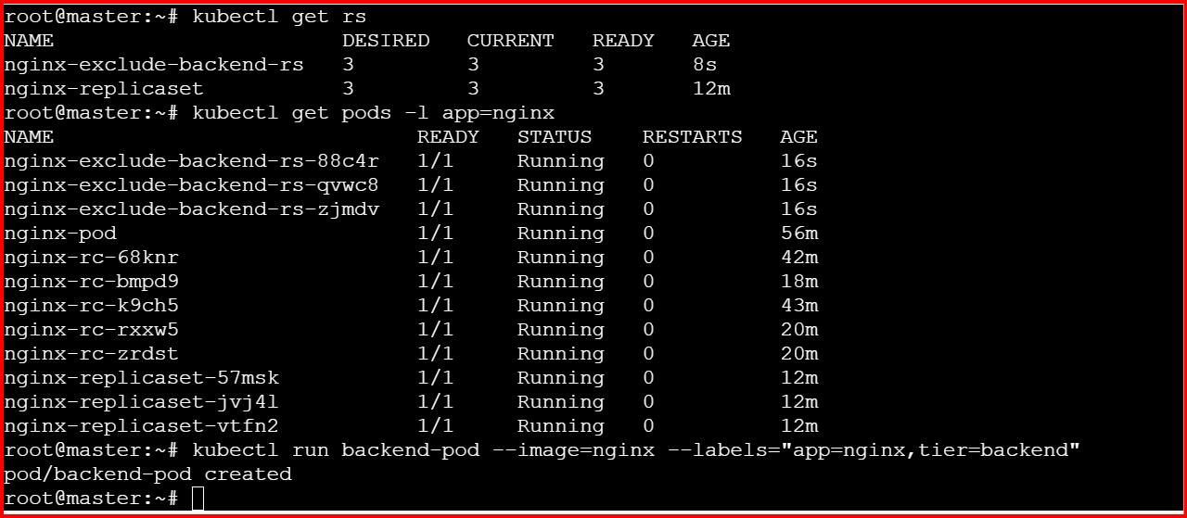

7.Test load balancing across multiple pods using a Node Port service.
I have created the nginx-replicaset as follows: vi nginx-replicaset.yml

apiVersion: apps/v1
kind: ReplicaSet
metadata:
name: nginx-rs
labels:
app: nginx
spec:
replicas: 3
selector:
matchLabels:
app: nginx
template:
metadata:
labels:
app: nginx
spec:
containers:
- name: nginx-container
image: nginx:latest
ports:
- containerPort: 80
---------------------------------------------------------------------------------------------------------------------------------
kubectl apply -f nginx-replicaset.yml
vi nginx-svc.yml

apiVersion: v1
kind: Service
metadata:
name: nginx-nodeport-svc
spec:
type: NodePort
selector:
app: nginx
ports:
- protocol: TCP
port: 80
targetPort: 80
nodePort: 30082
------------------------------------------------------------------------------------------------------------------------------------
Kubectl apply –f nginx-svc.yml
kubectl get svc

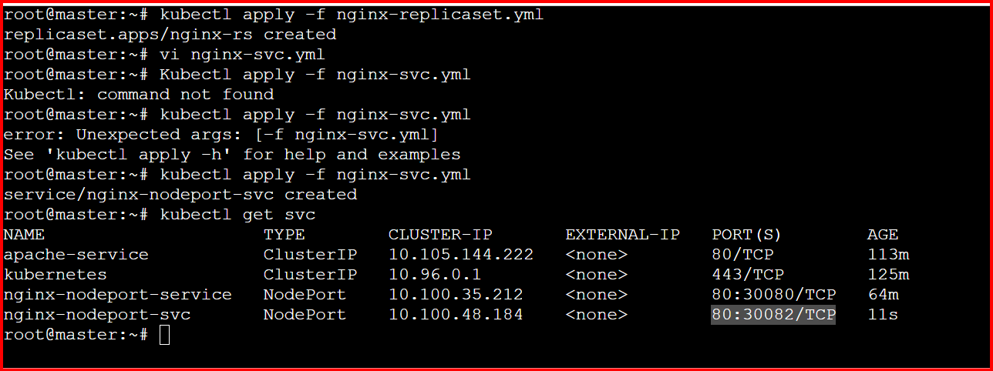

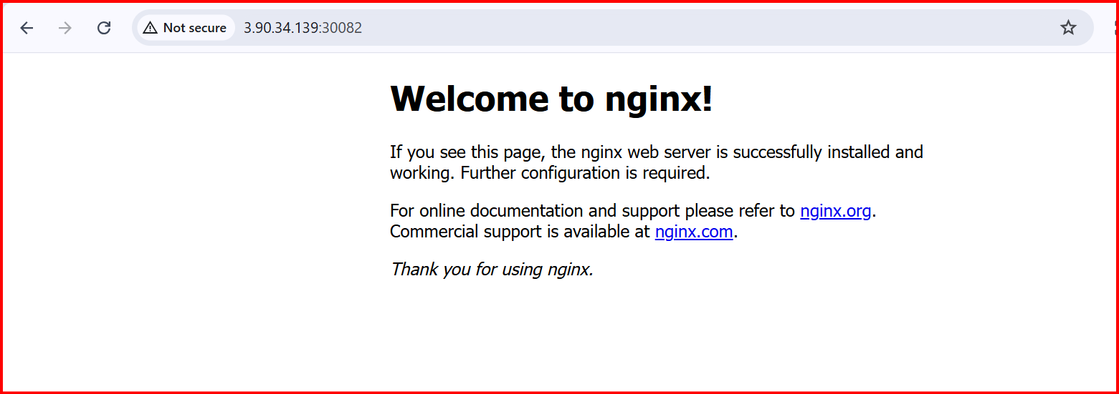

8.Delete a Replication Controller without affecting the running pods.
kubectl get rc
kubectl delete rc nginx-rc --cascade=orphan
kubectl get pods
